SonarQube Integration Project Submission (Address Book Module)
- Project Shared
I have integrated SonarQube Community Build with my Java project:
✅ProjectName:AddressBookSystem
✅Module Included: Address Book Module
✅Type: Core Java + Eclipse Project
✅Source Folder: src
✅Compiled Output Folder: bin

- Screenshots Provided
I have attached screenshots of:
- Project Execution
Output of AddressBookSystem running successfully in Eclipse / Console
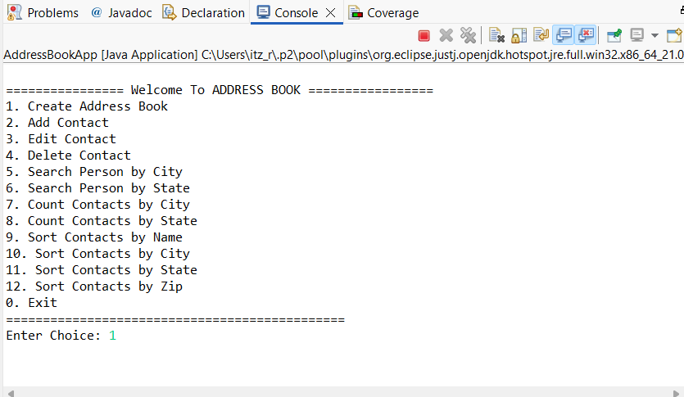
- SonarQube Report
- SonarQube Dashboard showing:
  - Quality Gate Status: Passed
  - Maintainability Issues
  - Coverage and Duplication Summary
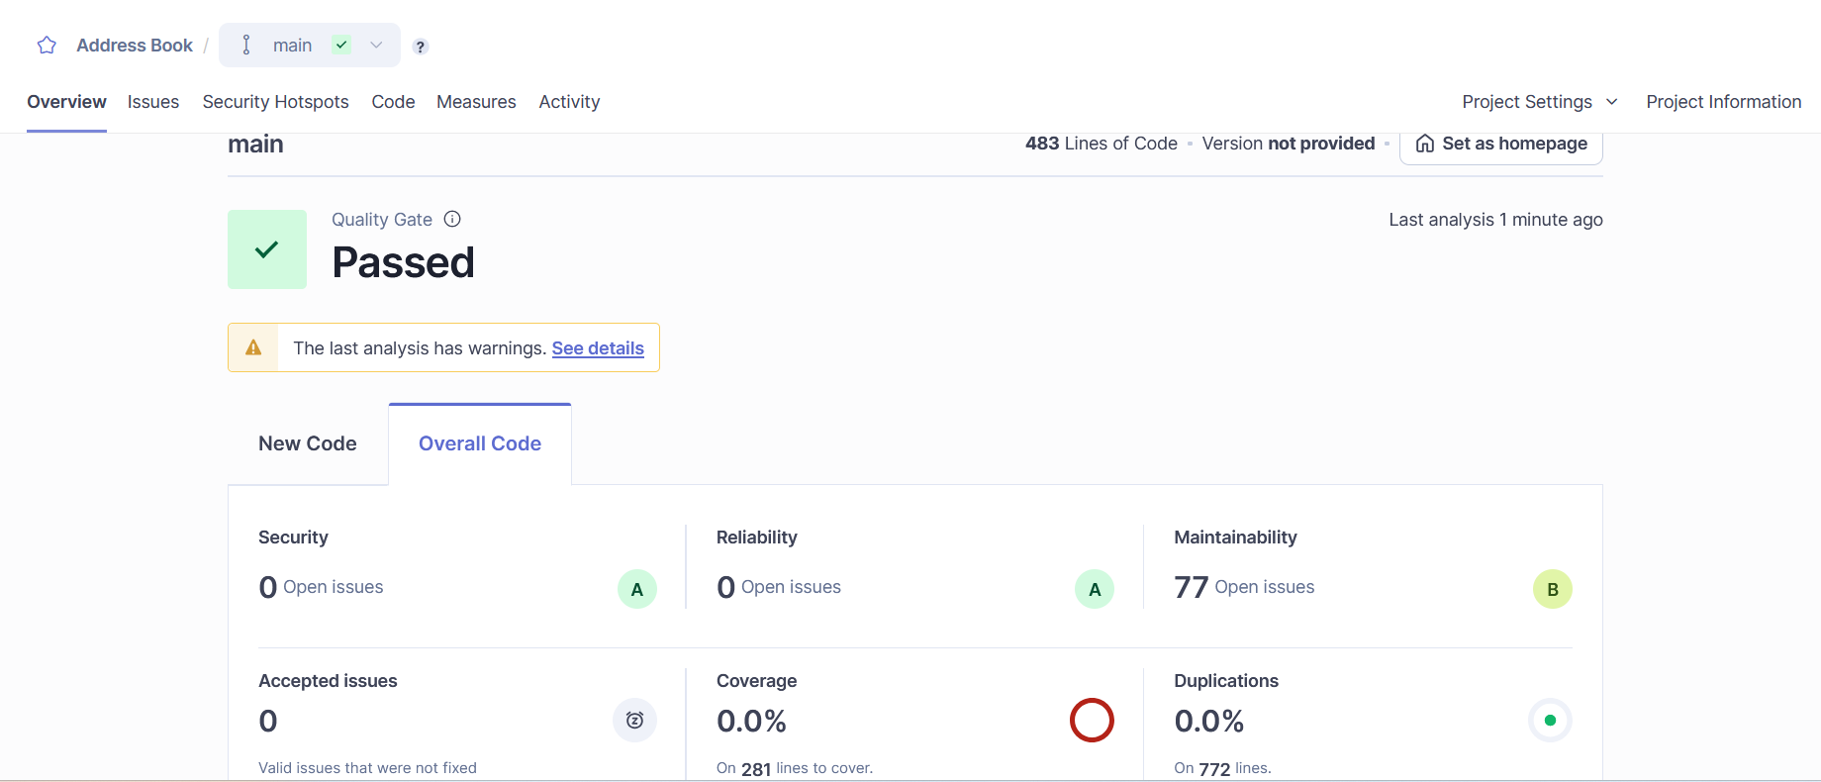

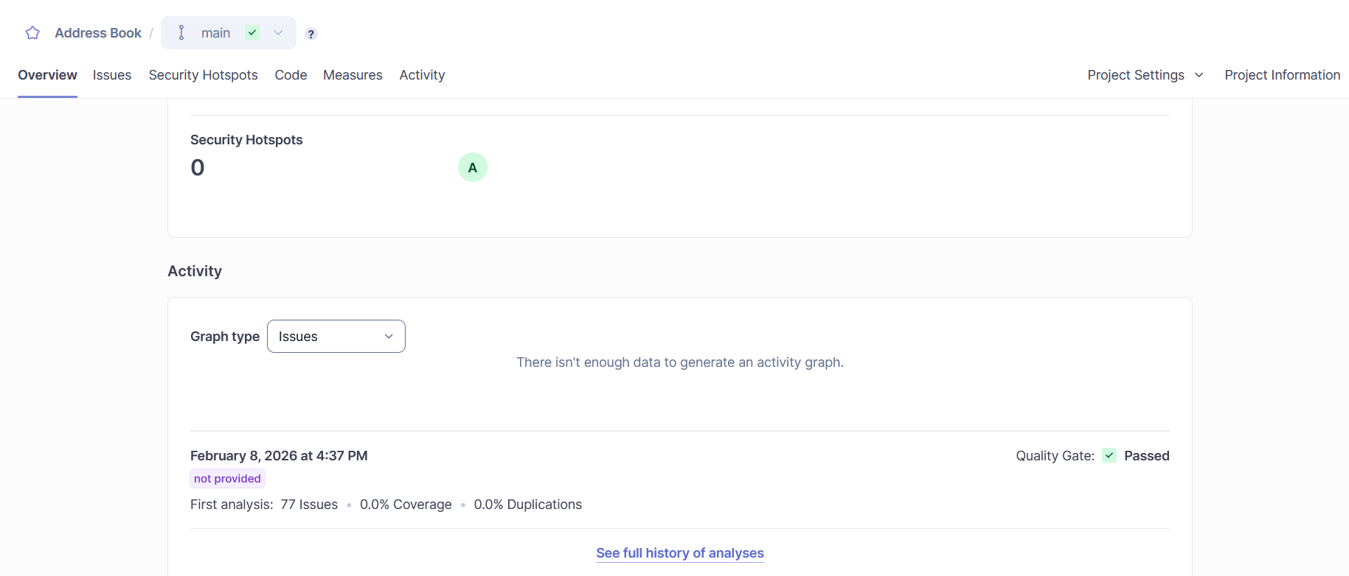

- Sonar Scanner Execution
  - Command Prompt output showing:
- ANALYSIS SUCCESSFUL
- Dashboard URL
(http://localhost:9000/dashboard?id=address-book&codeScope=overall)

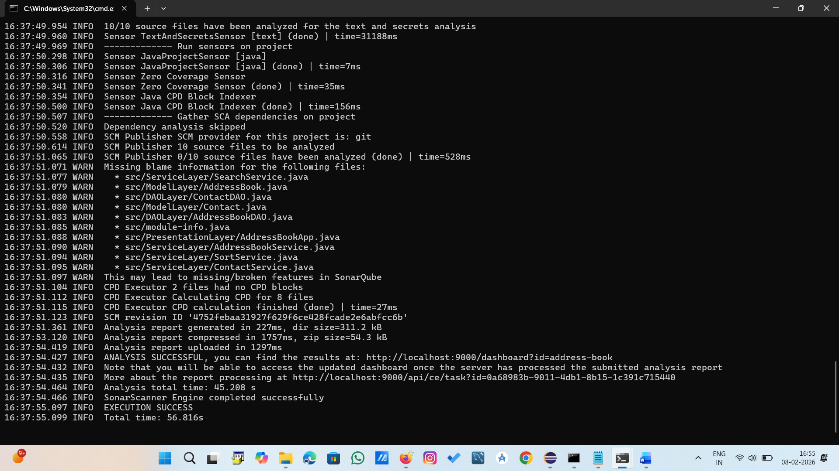

3) Step-by-Step Procedure Followed (SonarQube Integration)
Step 1: Install SonarQube
  - Download SonarQube Community Build for Windows
  - Extract it to a folder (example):C:\sonarqube-26.2.0\
  - Open Command Prompt as Administrator
  - Go to:sonarqube\bin\windows-x86-64\
  - Run:StartSonar.bat
Step 2: Verify SonarQube is Running
- Open browser:http://localhost:9000
- Login using default credentials:
  - Username: admin
  - Password: admin
- Set new password after login
Step 3: Create a New Project in SonarQube
  - Click Create Project
  - Enter Project Key:address-book
  - Generate a token (used for scanner authentication
Step 4: Download SonarScanner
  - Download SonarScanner CLI for Windows
  - Extract it (example):C:\sonar-scanner-8.0.1\
  - Add the bin folder to system PATH:C:\sonar-scanner-8.0.1\bin
Step 5: Compile the Java Project
SonarQube needs .class files for Java analysis.
In Eclipse project folder, compile classes into bin.
(For Eclipse projects, bin is created automatically when project builds.)
Step 6: Run Sonar Scanner
Open Command Prompt inside the project folder:
Example:C:\Users\...\eclipse-workspace\AddressBookSystem>
Run:
sonar-scanner.bat -D"sonar.projectKey=address-book" -D"sonar.sources=src" -D"sonar.java.binaries=bin" -D"sonar.host.url=http://localhost:9000" -D"sonar.token=TOKEN"

Step 7: View the SonarQube Report
Afterexecution, open:http://localhost:9000/dashboard?id=address-book
This displays:
  - Code Smells
  - Bugs
  - Vulnerabilities
  - Quality Gate Status

4) Methodology / Approach Used (Classroom Method)
Approach Followed
I followed the same approach used in the classroom:
✅Manual SonarQube Integration using SonarScanner CLI
This method includes:
- Running SonarQube Server locally
- Creating project in SonarQube UI
- Generating token
- Running SonarScanner command from project folder
- Viewing analysis report in SonarQube dashboard
Note about Different Approaches
Different approaches can also be used to integrate SonarQube, such as:
- SonarQube integration using Maven
- SonarQube integration using Gradle
- SonarQube integration using Jenkins CI/CD
- SonarLint plugin in Eclipse for live analysis
But in this project, I used the classroom method: SonarScanner CLI.
5) SonarQube Analysis Result Summary
From the report:
✅ Quality Gate: PASSED
✅ Security Issues: 0
✅ Reliability Issues: 0
⚠ Maintainability Issues: 77 Code Smells
🧪 Coverage: 0% (JUnit not added)
♻ Duplications: 0%

